CHAPTER FOUR

ANALYSIS OF THE PROPOSED SYSTEM

4.0 Overview of the Proposed System
The proposed system, titled Student Financial Mobile Platform, is a mobile-based financial platform designed to improve and modernize the fee payment process for students of Koforidua Technical University. The system aims to eliminate the inefficiencies associated with the current USSD-based payment approach by introducing a centralized, secure, and user-friendly mobile application for handling student financial transactions.
The system will be developed using a cross-platform mobile framework (React Native), a PHP-based RESTful backend API, and a MySQL database for secure data storage and management. It will integrate mobile money services and other digital payment gateways to ensure seamless and real-time transaction processing.
Unlike the existing USSD system, the proposed application will provide students with a complete financial dashboard, enabling them to initiate payments, track transactions, and download digital receipts in PDF format. The system is designed to enhance transparency, accessibility, and efficiency in institutional financial operations.

4.0.1 Functional Requirements
The functional requirements describe the specific operations that the proposed system must perform. The system shall:
- Allow students to log in using email and password.
- Enable secure authentication and verification of student identity.
- Provide multiple payment options (mobile money, bank transfer, and digital wallets).
- Process fee payments in real time through integrated payment gateways.
- Generate instant payment confirmations after successful transactions.
- Provide downloadable PDF receipts for all completed transactions.
- Maintain a transaction history dashboard for each student.
- Send real-time notifications for payment status updates.
- Allow students to view outstanding fees and payment balances.
- Enable administrators to monitor and verify payment records.

4.0.2 Non-Functional Requirements
The non-functional requirements define the quality attributes of the system. The proposed system shall ensure the following:
1. Performance
The system must process transactions within a few seconds to ensure real-time user experience.
2. Security
The system must implement strong authentication, encrypted communication (HTTPS), and secure storage of user data to prevent unauthorized access.
3. Usability
The mobile application must have a simple, intuitive, and user-friendly interface suitable for all student users.
4. Reliability
The system must ensure high availability with minimal downtime, especially during peak registration periods.
5. Scalability
The system must be capable of handling increasing numbers of users and transactions without performance degradation.
6. Maintainability
The system must be easy to update, debug, and improve over time using modular architecture.
7. Portability
The application must be compatible with both Android and iOS devices using a single codebase.
8. Accuracy
All financial transactions must be processed accurately with proper validation and record-keeping.

4.1 Major Features/Components of the Proposed System
The Student Financial Mobile Platform will consist of the following major components:
1. User Authentication Module
Handles login, password recovery, and secure session management.
2. Student Dashboard
Provides an overview of student financial status, including fees due, payment history, and notifications.
3. Payment Processing Module
Handles integration with mobile money APIs and bank payment gateways to process transactions securely.
4. Transaction Management Module
Stores and displays all payment records, including successful and pending transactions.
5. Receipt Generation Module
Automatically generates downloadable PDF receipts after every successful payment.
6. Notification Module
Sends real-time alerts for payment confirmation, failures, and updates.
7. API Layer (Backend Services)
Provides secure communication between the mobile application and the database/payment systems.

4.2 Benefits/Advantages of the Proposed System
The proposed system provides several benefits to students, administrators, and the institution as a whole:
1. Improved Accessibility
Students can access the system anytime and anywhere using their mobile devices. This eliminates the need to visit campus offices physically or rely on limited-service hours. The convenience of mobile access ensures that students can make payments and view their records at their preferred time and location.

2. Real-Time Payment Processing
Payments are processed instantly, reducing delays in registration and academic activities. Once a transaction is completed, the system automatically updates the student's payment status, allowing them to proceed with other academic processes without waiting for manual confirmation.
3. Enhanced Transparency
All transactions are recorded and visible to users, reducing errors and disputes. Students can easily track their payment history, while administrators can monitor transactions through the system dashboard. This transparency helps build trust and accountability among all stakeholders.
4. Digital Receipt Generation
Students receive permanent PDF receipts that can be downloaded and stored safely. These receipts serve as official proof of payment and can be accessed whenever needed for verification, scholarship applications, or other administrative purposes.
5. Reduced Administrative Workload
Automation of payment tracking reduces manual verification tasks for finance staff. Instead of spending time checking payment records and issuing receipts manually, staff can focus on more strategic and student-support activities, leading to greater operational efficiency.
6. Better User Experience
The mobile application provides a modern, intuitive interface compared to USSD systems. Features such as easy navigation, instant notifications, payment history, and receipt downloads create a smoother and more user-friendly experience for students.
7. Improved Security
Encryption and authentication mechanisms protect user data and financial transactions. Secure login procedures, data encryption, and controlled access ensure that sensitive information remains confidential and protected from unauthorized access or cyber threats.
8. Centralized Financial Records
All payment data is stored in a structured database for easy retrieval and auditing. This centralization improves record management, simplifies report generation, supports decision-making, and ensures compliance with financial auditing requirements.
9. Faster Financial Reporting
The system can automatically generate financial reports based on recorded transactions. This enables administrators to monitor revenue, track payment trends, and make informed financial decisions without the need for extensive manual data compilation.
10. Increased Accuracy
Automated payment processing minimizes human errors that commonly occur during manual record keeping. Accurate transaction records improve data integrity and reduce the likelihood of discrepancies in student accounts.
11. Improved Communication
The application can provide instant notifications and confirmations for successful transactions. Students are kept informed about payment statuses, deadlines, and important financial updates, reducing confusion and missed payments.
12. Scalability and Future Integration
The system can easily accommodate a growing number of students and transactions. It can also be integrated with other institutional systems such as student information systems, academic portals, and accounting software, enhancing overall institutional efficiency.

4.3 System Context Diagram of the Proposed System
The context diagram of the proposed system represents the Student Financial Mobile Platform Application as a single system interacting with external entities.
External Entities:
- Student
- Mobile Money Service Providers (e.g., MTN Mobile Money, Airtel Tigo Money)
- Bank Payment Gateway
- University Finance Department
System:
Student Financial Mobile Platform Application
Data Flow Description:
- The student initiates a payment request through the mobile application.
- The system processes the request and sends it to the Mobile Money/Bank Gateway.
- The payment gateway verifies and processes the transaction.
- A confirmation response is returned to the system.
- The system updates the database and sends a confirmation notification to the student.
- The system also shares transaction records with the University Finance Department for verification and reporting.

4.3.1 Context Diagram (Text Representation)
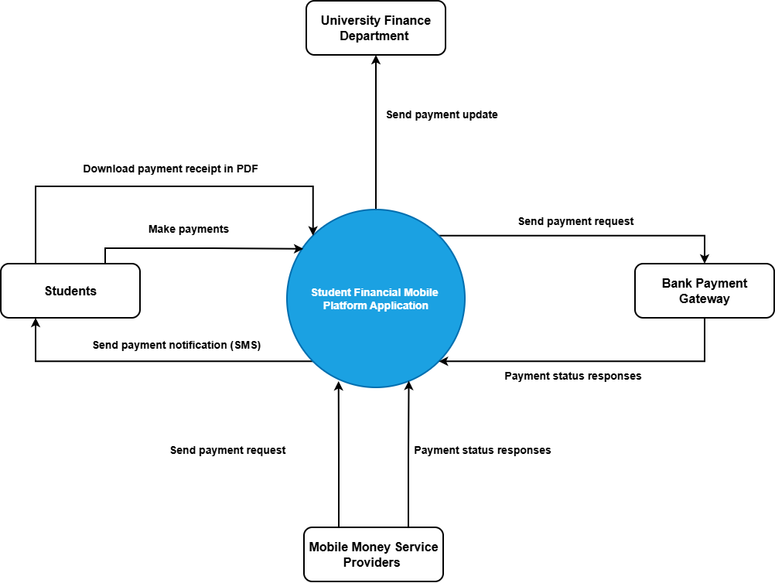

The context diagram provides a high-level representation of the interaction between the Student Financial Mobile Platform and external entities. It illustrates how information flows into and out of the system while defining the system boundary.
The student serves as the primary user of the application by initiating payments, viewing financial records, and receiving notifications. Payment service providers act as external systems responsible for processing financial transactions securely and returning transaction responses to the application.
The university finance department receives transaction data from the system for verification, reconciliation, reporting, and auditing purposes. Through these interactions, the proposed platform acts as an intermediary that facilitates efficient communication between students, payment providers, and university administrators.
The context diagram also highlights the centralized nature of the proposed system, where all transaction information is processed, stored, and managed within a single integrated platform.

4.4 Summary of the Chapter
This chapter provided a comprehensive analysis of the proposed Student Financial Mobile Platform designed for Koforidua Technical University. The chapter described the objectives of the proposed system, its functional and non-functional requirements, major components, and anticipated benefits.
The analysis demonstrated how the system addresses the challenges associated with the existing USSD-based payment solution by introducing real-time transaction processing, digital receipt generation, centralized record management, and enhanced security mechanisms. These improvements are expected to enhance the efficiency of fee payment processes while reducing the burden on both students and university staff.
Furthermore, the chapter examined the key modules that make up the proposed system, including user authentication, payment processing, transaction management, notification services, receipt generation, and backend API services. Each module plays a critical role in ensuring the smooth operation of the application and the effective management of student financial transactions.
The chapter also highlighted the numerous advantages of the proposed system, such as improved accessibility, increased transparency, enhanced security, reduced administrative workload, better financial reporting, and greater accuracy in transaction processing. These benefits collectively contribute to a more reliable and user-friendly financial management environment for students and university administrators.
In addition, the context diagram presented in this chapter illustrated the interactions between the proposed system and external entities, including students, mobile money service providers, bank payment gateways, and the university finance department. This representation provided a clear understanding of how data and financial transactions flow through the system and how different stakeholders interact with the platform.
Overall, the analysis confirms that the proposed Student Financial Mobile Platform is a viable and effective solution for modernizing student fee payment processes at Koforidua Technical University. By leveraging mobile technology and digital payment services, the system is expected to improve service delivery, strengthen financial accountability, and support the university's broader digital transformation objectives.
The outcomes of this chapter provide a solid foundation for the next phase of the project, which focuses on the design and implementation of the system architecture, database structure, user interfaces, and integration mechanisms required to realize the proposed solution successfully.

